-----------------------------------------------------------------------------------------------------------------------------------------
Instructions: Given commands to compile and run java source files.

Note: 1) Quadratic, Linear probing hash tables are implemented as optional ones.
2) For hashing with chaining there is an implementation which maintains the insertion order.
-----------------------------------------------------------------------------------------------------------------------------------------
Project code requires minimum java version 1.5

Compile:
javac CuckooHashTableRun.java

javac DoubleHashingHashTableRun.java

javac QuadraticProbeHashTableRun.java
javac LinearProbeHashTableRun.java

javac SeperateChainHashTableRun.java
javac SeparateChainLinkedHashTable.java

Runs: java CuckooHashTableRun.java

java DoubleHashingHashTableRun.java

java QuadraticProbeHashTableRun.java
java LinearProbeHashTableRun.java

java SeperateChainHashTableRun.java
java SeparateChainLinkedHashTable.java

-----------------------------------------------------------------------------------------------------------------------------------------
Analyisis:
-----------------------------------------------------------------------------------------------------------------------------------------

- Quadratic probing is the fastest hash table implementation for inserts and find operations combined

- Cuckoo hashing and separate chaining lags in inserts considerably.

- Cuckoo is fastest for remove operations.

-----------------------------------------------------------------------------------------------------------------------------------------
Results: Average time is seconds (Time includes reading the input file)
Have to check excluding the file reading time.

Intial size of hashTables is selected as 100000
On average requires 3-4 rehashes of the tables.
-----------------------------------------------------------------------------------------------------------------------------------------

Data Structure | in4.txt | in5.txt | In6.txt
Cuckoo hashing | 1.52 | 1.49 | 1.52
Double hashing | 1.29 | 1.17 | 1.31
Quadratic probing | 1.02 | 1.01 | 1.09
Linear probing | 1.22 | 1.19 | 1.19
Separate Chaining | 1.82 | 1.57 | 1.66
Separate Chaining  (with insertion order, optimized for findMin,findMax) | 3.09 | 3.09 | 3.1

-----------------------------------------------------------------------------------------------------------------------------------------
Sample runs
-----------------------------------------------------------------------------------------------------------------------------------------

 | in4.txt | In5.txt | In6.txt
Cuckoo hashing | Time taken: 1.506 secs  Insert: 334134  Find: 332874  Remove: 333  RemoveValue: 1  FindMin: 1  FindMax: 2  Size: 1  Total:667346  Sum: 80924724796868414  Find failed count: 0  -----------------------------------  Min:14810482189031  Max:9223358845662725584  Total size:333800 | Time taken: 1.528 secs  Insert: 334147  Find: 332783  Remove: 333  RemoveValue: 1  FindMin: 1  FindMax: 1  Size: 2  Total:667268  Sum: 89152739468624086  Find failed count: 0  ----------------------------------  Min:6466664450347  Max:9223353899843859821  Total size:333813 | Time taken: 1.522 secs  Insert: 333540  Find: 333048  Remove: 333  RemoveValue: 1  FindMin: 1  FindMax: 2  Size: 1  Total:666926  Sum: 258862459865900418  Find failed count: 0  ----------------------------------  Min:15090378601405  Max:9223367465527925267  Total size:333206
Double hashing | Time taken: 1.305 secs  Insert: 334134  Find: 332874  Remove: 333  RemoveValue: 1  FindMin: 1  FindMax: 2  Size: 1  Total:667346  Sum: 80924724796868414  Find failed count: 0  -------------------------------  Min:14810482189031  Max:9223358845662725584  Total size:333800 | Time taken: 1.177 secs  Insert: 334147  Find: 332783  Remove: 333  RemoveValue: 1  FindMin: 1  FindMax: 1  Size: 2  Total:667268  Sum: 89152739468624086  Find failed count: 0  --------------------------------  Min:6466664450347  Max:9223353899843859821  Total size:333813 | Time taken: 1.275 secs  Insert: 333540  Find: 333048  Remove: 333  RemoveValue: 1  FindMin: 1  FindMax: 2  Size: 1  Total:666926  Sum: 258862459865900418  Find failed count: 0  ------------------------------------  Min:15090378601405  Max:9223367465527925267  Total size:333206
Quadratic probing | Time taken: 1.021 secs  Insert: 334134  Find: 332874  Remove: 333  RemoveValue: 1  FindMin: 1  FindMax: 2  Size: 1  Total:667346  Sum: 80924724796868414  Find failed count: 0  --------------------------------------  Min:14810482189031  Max:9223358845662725584  Total size:333800 | Time taken: 1.009 secs  Insert: 334147  Find: 332783  Remove: 333  RemoveValue: 1  FindMin: 1  FindMax: 1  Size: 2  Total:667268  Sum: 89152739468624086  Find failed count: 0  --------------------------------------  Min:6466664450347  Max:9223353899843859821  Total size:333813 | Time taken: 1.091 secs  Insert: 333540  Find: 333048  Remove: 333  RemoveValue: 1  FindMin: 1  FindMax: 2  Size: 1  Total:666926  Sum: 258862459865900418  Find failed count: 0  -------------------------------  Min:15090378601405  Max:9223367465527925267  Total size:333206
Linear probing | Time taken: 1.225 secs  Insert: 334134  Find: 332874  Remove: 333  RemoveValue: 1  FindMin: 1  FindMax: 2  Size: 1  Total:667346  Sum: 80924724796868414  Find failed count: 0  --------------------------------------  Min:14810482189031  Max:9223358845662725584  Total size:333800 | Time taken: 1.204 secs  Insert: 334147  Find: 332783  Remove: 333  RemoveValue: 1  FindMin: 1  FindMax: 1  Size: 2  Total:667268  Sum: 89152739468624086  Find failed count: 0  ---------------------------------  Min:6466664450347  Max:9223353899843859821  Total size:333813 | Time taken: 1.196 secs  Insert: 333540  Find: 333048  Remove: 333  RemoveValue: 1  FindMin: 1  FindMax: 2  Size: 1  Total:666926  Sum: 258862459865900418  Find failed count: 0  ---------------------------  Min:15090378601405  Max:9223367465527925267  Total size:333206
Separate Chaining | Time taken: 1.804 secs  Insert: 334134  Find: 332874  Remove: 333  RemoveValue: 1  FindMin: 1  FindMax: 2  Size: 1  Total:667346  Sum: 80924724796868414  Find failed count: 0  ---------------------------------  Min:14810482189031  Max:9223358845662725584  Total size:333800 | Time taken: 1.576 secs  Insert: 334147  Find: 332783  Remove: 333  RemoveValue: 1  FindMin: 1  FindMax: 1  Size: 2  Total:667268  Sum: 89152739468624086  Find failed count: 0  ---------------------------------  Min:6466664450347  Max:9223353899843859821  Total size:333813 | Time taken: 1.714 secs  Insert: 333540  Find: 333048  Remove: 333  RemoveValue: 1  FindMin: 1  FindMax: 2  Size: 1  Total:666926  Sum: 258862459865900418  Find failed count: 0  --------------------------------  Min:15090378601405  Max:9223367465527925267  Total size:333206
Separate Chaining  (with insertion order, optimized for findMin,findMax) | Time taken: 3.095 secs  Insert: 334134  Find: 332874  Remove: 333  RemoveValue: 1  FindMin: 1  FindMax: 2  Size: 1  Total:667346  Sum: 80924724796868414  Find failed count: 0  ---------------------------------  Min:14810482189031  Max:9223358845662725584  Total size:333800 | Time taken: 3.083 secs  Insert: 334147  Find: 332783  Remove: 333  RemoveValue: 1  FindMin: 1  FindMax: 1  Size: 2  Total:667268  Sum: 89152739468624086  Find failed count: 0  ----------------------------  Min:6466664450347  Max:9223353899843859821  Total size:333813 | Time taken: 3.104 secs  Insert: 333540  Find: 333048  Remove: 333  RemoveValue: 1  FindMin: 1  FindMax: 2  Size: 1  Total:666926  Sum: 258862459865900418  Find failed count: 0  ---------------------------------------  Min:15090378601405  Max:9223367465527925267  Total size:333206

Data Structure
Cuckoo hashing | 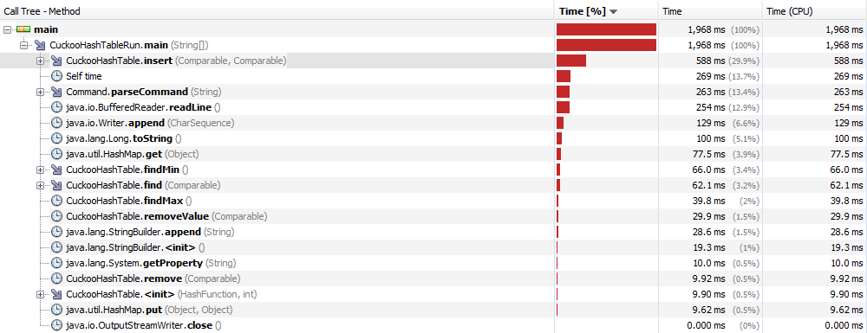
Double hashing | 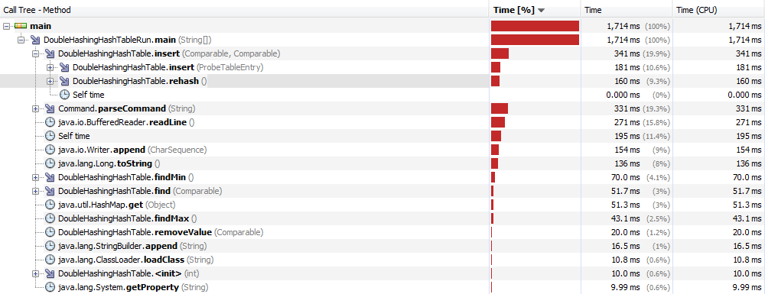
Quadratic probing | 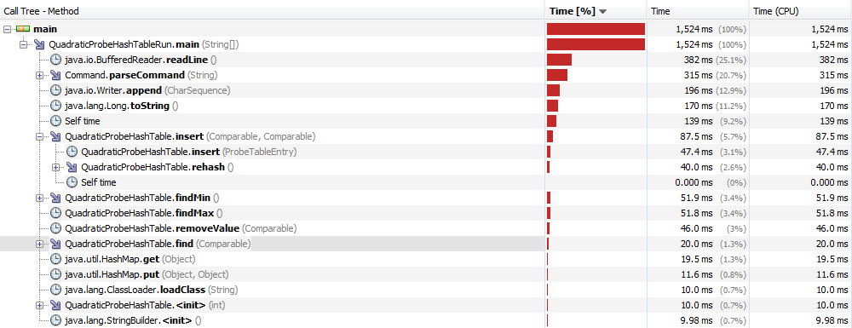
Linear probing | 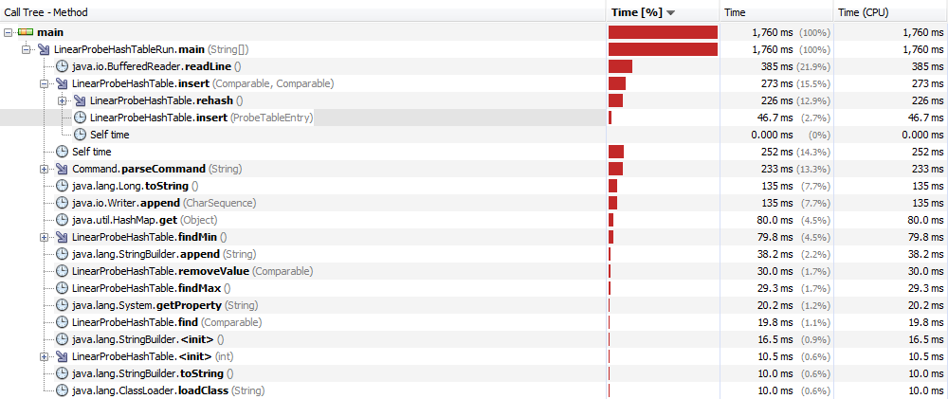
Separate Chaining | 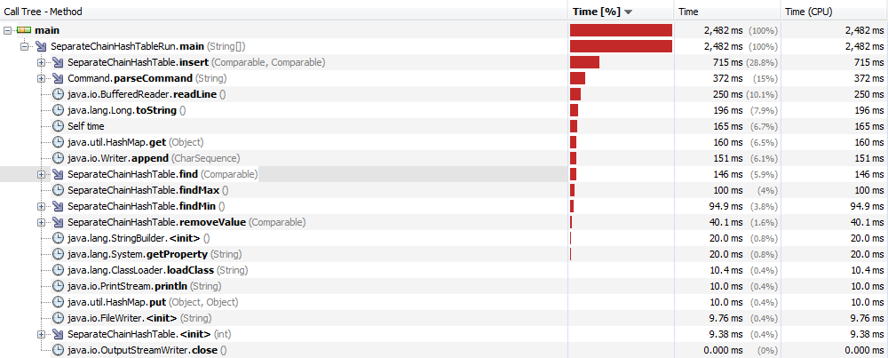
Separate Chaining  (with insertion order, optimized for findMin,findMax) | 